

**Raising Nemo: Parental care in the clown anemonefish**

Featured scientist: Tina Barbasch (she/her) from Boston University

*Research Background:*

When animals are born, some offspring are able to survive on their own, while others rely on **parental care**. Parental care can take many forms. One or both parents might help raise the young, or in some species, other members of the group help them out. The more time and energy the parents invest, the more likely it is that their offspring will survive. However, parental care is costly for the parents. When parents invest time, energy, and resources in their young, they are unable to invest as much in other activities, like finding food for themselves. This results in a **tradeoff**, or a situation where there are costs and benefits to the decisions that must be made. Parents must balance their time between caring for their offspring and other activities.

The severity of the tradeoff between parental care and other activities may depend on certain environmental conditions. For example, if there is a lot of food available, parents may spend more time tending to their young because finding food for themselves takes less time and energy. Scientists have wondered if parents adjust their parental care strategies in response to environmental changes.

Tina is a scientist studying the clown anemonefish. She is interested in how parental care in this species changes in response to the environment. She chose to study anemonefish because they use an interesting system to take care of their young

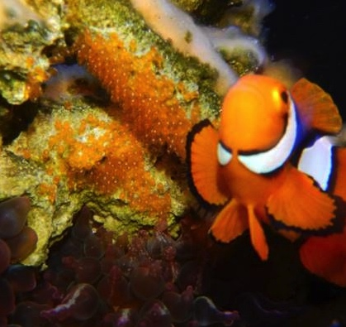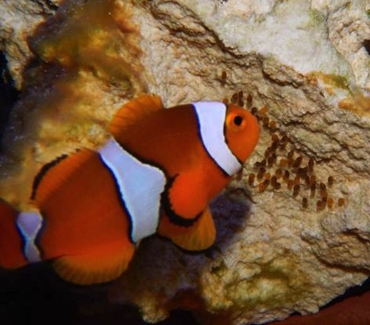

Clown anemonefish (*Amphiprion percula*) caring for their eggs. Parents will fan the eggs to increase oxygen by the nest, or mouth them to remove dead eggs and clean the nest.

and because the environment is always changing in the coral reefs where they live.

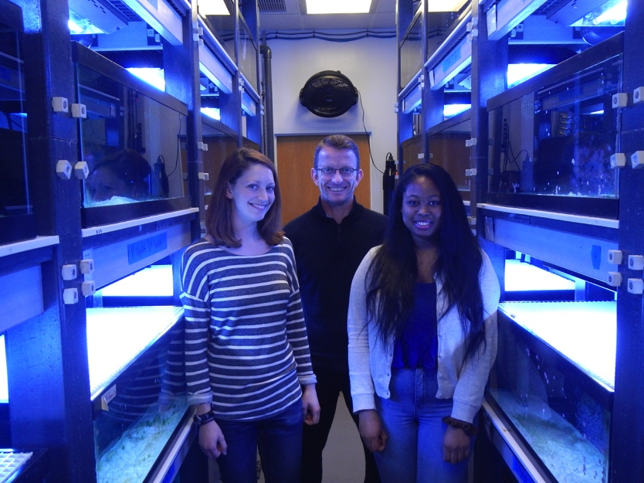

Tina (left) with other members of her lab. The glowing blue tanks around them all contain anemonefish.

Anemonefish form monogamous pairs and live in groups of up to six individuals. The largest female is in charge of the group. Only the largest male and female get to mate and take care of the young. Both parents care for eggs by tending them, mouthing the eggs to clean the nest and remove dead eggs, and fanning eggs with their fins to oxygenate them. A single pair may breed together tens or even hundreds of times over their lifetimes. But here is the cool part — anemonefish can change their sex! If the largest female dies, the largest male changes to a female and the next largest fish in line becomes the new breeding male. That means that a single fish may have the opportunity to be both a mother and a father during its lifetime.

On the reef, anemonefish groups also experience shifts in how much food is available. In years with a lot of food, the breeding pair has many young, and in years with little food, they do not breed as often. Specifically, Tina thought that food availability would determine how much time and energy parents invest in parental care behaviors. She collected data from 20 breeding pairs of fish, 10 of which she gave half rations of food and 10 of which she gave full rations. The experiment ran for six lunar months. Every time a pair laid a clutch of eggs, Tina waited seven days and then took a 15-minute video of the parents and their nest. She watched the videos and measured three parental care behaviors for males and females: mouthing, fanning, and total time spent tending. Some pairs laid eggs more than once, so she averaged these behaviors across the six months of the experiment. Tina predicted that parents fed a full ration of food would perform more parental care behaviors, and for a longer amount of time than parents fed a half ration.

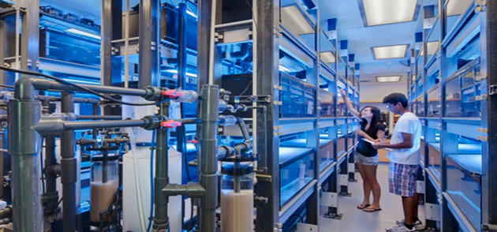

Undergraduates working with clown anemonefish in the lab.

*Scientific Question*: How does food resource availability influence parental care in the clown anemonefish?

*What is the hypothesis?* Find the hypothesis in the Research Background and underline it. A hypothesis is a proposed explanation for an observation, which can then be tested with experimentation or other types of studies.

*Scientific Data:*

**Use the data below to answer the scientific question:**



*\*Standard error (SE) tells us how confident we are in our estimate of the mean and depends on the number of replicates in an experiment and the amount of variation in the data. When there is lower replication and higher variation, SE bars are large. A large SE means we are not very confident, while a small SE means we are more confident.*

Which data will you graph to answer the question?

Independent variables:

Dependent variables:

*Below are graphs of the data*: Identify any changes, trends, or differences you see in the graph. Draw arrows pointing out what you see and write one sentence describing what you see next to each arrow.







*Interpret the data:*

Make a claim that answers the scientific question - How does food resource availability influence parental care in the clown anemonefish?

What evidence was used to write your claim? Reference specific parts of the table or graphs.

Explain your reasoning and why the evidence supports your claim. Connect the data back to what you learned about how environmental conditions can influence parental care.

Did the data support Tina’s hypothesis? Use evidence to explain why or why not. If you feel the data were inconclusive, explain why.

*Your next steps as a scientist:* Science is an ongoing process. What new question(s) should be investigated to build on Tina’s research? How do your questions build on the research that has already been done?