Title
Featured scientist: [name & preferred pronouns] from [institution]

Research Background: Write clearly and concisely, keeping in mind your audience. Keep sentences short, and break compound sentences into simpler sentences. Remove any unnecessary words, and use plain language, avoiding jargon and technical terms. Keep paragraphs short (~100-200 words per paragraph).
Paragraph 1: Scientific background knowledge. Get the reader excited about the research – what do they need to know to understand the topic and experiment?
Paragraph 2: Bring in exploration and discovery – discuss how you first became interested in the topic and how you developed your hypothesis. If applicable, discuss prior experiences and preliminary data that lead to the study.
Paragraph 3: Describe your methods and how you collected your data. What observations first lead you to develop your scientific question? What is a simple description of the study design, including variables measured? Based on your observations what are your predictions for the study?

Include pictures of the experiment and study species. A picture of the researcher collecting data in the lab or field is best. Please email your pictures to datanuggetsk16@gmail.com and provide captions if necessary.

Scientific Question: Ask a scientific question that can be answered with the data provided. A scientific question should frame how your research contributes to the field, not simply ask for a summary of patterns in the data. Avoid yes/no questions.

Scientific Data:

Use the data below to answer the scientific question: Include a table of data from your research. Please email your data in Excel to datanuggetsk16@gmail.com and include any necessary descriptions of variables or units. You may have to simplify the data so that it is manageable for a student who is graphing by hand, but don’t worry if your data is messy – that is part of research! You may include data on other variables so students will have to figure out those that address the scientific question.

Please provide necessary summary statistics, such as means, standard deviations, standard errors, or equations for lines of best fit. We will include this information for teachers, along with necessary notes to help communicate data to students.

What data will you graph to answer the question?
Independent variable:

Dependent variable:

Draw your graph below: Identify any changes, trends, or differences you see in your graph. Draw arrows pointing out what you see, and write one sentence describing what you see next to each arrow.

Please provide a graph of your data in Excel. We will provide the graph for teachers and use the file to create three graph types for students:

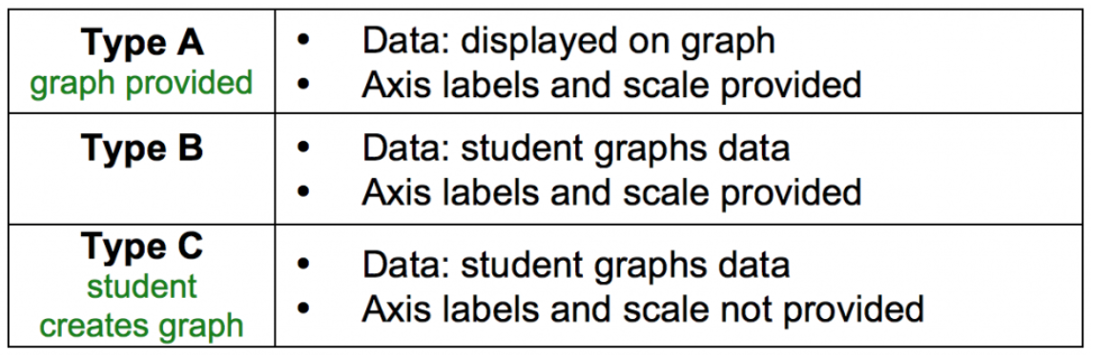

Interpret the data: In this section, we are asking students to construct explanations by interacting with quantitative information in three different ways: 1. Observe and identify trends in data, 2. Support a claim using data as evidence, and 3. Interpret data in context of science.

Make a claim that answers the scientific question.

Write out the claim, or conclusion about a problem. The claim can be written as a statement that answers the scientific question.

What evidence was used to write your claim? Reference specific parts of the table or graph.

Data becomes evidence when it supports the claim and helps answer the scientific question. Indicate what numbers from the table or points on the graph best support the claim, or what parts of the graph students could circle for support.

Explain your reasoning and why the evidence supports your claim. Connect the data back to what you learned about [major theme from Research Background].

Describe your reasoning or the justification, built from scientific principles, for why the evidence supports the claim. Reasoning should contain two parts: (1) Why does the evidence support the claim? (2) What is the underlying science concept?

Your next steps as a scientist:

Science is an ongoing process. What new question(s) should be investigated to build on [scientist name]’s research? How do your questions build on the research that has already been done?

Describe your next steps as a scientist, even if they are just future plans. The teacher can then share these with the class when they discuss this section. List any future questions you tested or plan to test in this study system. Are there questions that students could address in their own inquiry experiment?

What future data should be collected to answer your question?

Independent variable(s):

Dependent variable(s):

For each variable, explain why you included it and how it could be measured.

Share any experimental methodology that would be useful for teachers when discussing this question with students.

What hypothesis are you testing in your experiment? A hypothesis is a proposed explanation for an observation, which can then be tested with experimentation or other types of studies.

Write out any hypotheses or mechanisms that you think could be operating in this system.

