Title - Make this catchy and interesting
Featured scientist: [name & preferred pronouns] from [institution]

Before you start, identify the research question and dataset you would like to share with students. This will help you craft your story to share in the Research Background. Try to reduce content so students can focus on the main message – less is more.
Research Background: Write clearly and concisely, keeping your audience in mind. Keep sentences short and break compound sentences into multiple simple sentences. Introduce 1-3 key terms for students to answer the question presented. Remove any unnecessary words and use plain language, avoiding jargon and technical terms. Keep paragraphs short (~100-200 words per paragraph).
Paragraph 1: Scientific background knowledge. Connect to a larger topic that students can relate to, if possible. Get the reader excited about the research.
Paragraph 2: Provide information about your specific study system. What do students need to know to understand the topic and experiment?
Paragraph 3: Share your personal story. Bring in exploration and discovery – discuss how you first became interested in the topic and how you developed your research question. Consider prior experiences and preliminary data that led to the study.
Paragraph 4: State your hypothesis and describe your methods. A hypothesis is an explanation for an observation, not just a description of the pattern you expect to observe.
Paragraph 5: Describe the experiment or study and your data variables. What is a simple description of the study design? What are the variables that were manipulated or measured? What would you expect to observe in these variables if your hypothesis were true?

Note: We work with you to highlight and feature unique aspects of your research and your science story. To help us do that, please include:
- Pictures of the experiment and study species. We have found images of the researcher collecting data in the lab or field to resonate and inspire students the most. Please email your pictures to datanuggetsk16@gmail.com and provide captions if necessary.

- Messy components of your research! Stories of unanticipated results or incidents that led to missing data are important for us to normalize these experiences for students. As we do science, we revise our methods and improve on what we did before.

- Additional resources, such as blogs, videos, research articles, and larger datasets to go along with your research. Teachers love being able to customize their implementation of your activity to fit their students’ needs. You can add a box for a teacher note in this file or email your ideas to us so we can help connect your ideas to the classroom environment.

Scientific Question: Ask a scientific question that can be answered with the data provided. A scientific question should frame how your research contributes to the field, not simply ask for a summary of patterns in the data. Avoid yes/no questions.

What is the hypothesis? Find the hypothesis in the Research Background and underline it. A hypothesis is a proposed explanation for an observation, which can then be tested with experimentation or other types of studies. Underline your hypothesis in the Research Background text.

Scientific Data:

Use the data below to answer the scientific question: Include a table of data from your research. Please email your data in Excel to datanuggetsk16@gmail.com and include any necessary descriptions of variables or units. You may have to simplify the data so that it is manageable for a student who is graphing by hand, but don’t worry if your data is messy – that is part of research! We aim to include these complexities in our activities to normalize the true process of science so students can relate to their own experiences.

Please provide necessary summary statistics, such as means, standard deviations, standard errors, or equations for lines of best fit. We will include this information for teachers, along with necessary notes to help communicate data to students.

What data will you graph to answer the question?
Independent variable:

Dependent variable:

Draw your graph below: Identify any changes, trends, or differences you see in your graph. Draw arrows pointing out what you see, and write one sentence describing what you see next to each arrow.

Please provide a graph of your data in Excel. We will provide the graph for teachers and use the file to create three graph types for students:

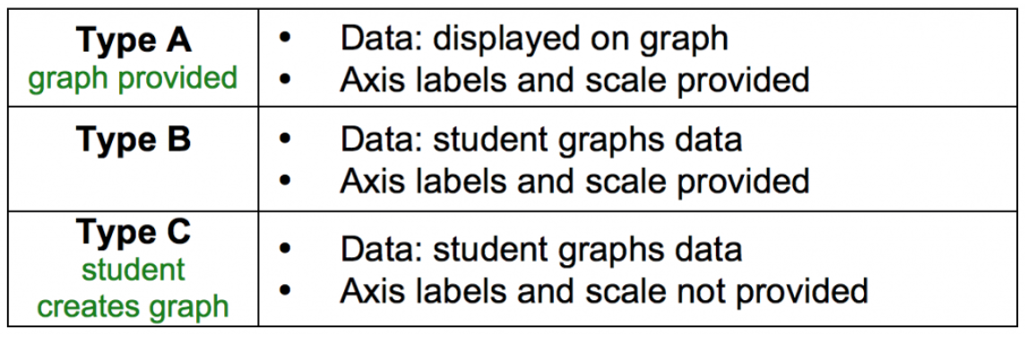

Interpret the data: In this section, we are asking students to construct explanations by interacting with quantitative information in three different ways: 1. Observe and identify trends in data, 2. Support a claim using data as evidence, and 3. Interpret data in context of science.

Make a claim that answers the scientific question.

Write out the claim, or conclusion about a problem. The claim can be written as a statement that answers the scientific question.

What evidence was used to write your claim? Reference specific parts of the table or graph.

Data becomes evidence when it supports the claim and helps answer the scientific question. Indicate what numbers from the table or points on the graph best support the claim, or what parts of the graph students could circle for support.

Explain your reasoning and why the evidence supports your claim. Connect the data back to what you learned about [major theme from Research Background].

Describe your reasoning or the justification, built from scientific principles, for why the evidence supports the claim. Reasoning should contain two parts: (1) Why does the evidence support the claim? (2) What is the underlying science concept?

Did the data support [scientist name]’s hypothesis? Use evidence to explain why or why not. If you feel the data are inconclusive, explain why.

Does the data support your hypothesis? In what way does the data follow predictions, and in what ways does it not? Are there alternative interpretations of the data? Are there alternative hypotheses or other mechanisms that could be operating? Students may be tempted to overstate experiment findings, so talk about what we can and can't conclude from the study. What data would be necessary to extend these findings?

Your next steps as a scientist: Science is an ongoing process. What new question(s) should be investigated to build on [scientist name]’s research? How do your questions build on the research that has already been done?

Describe your next steps as a scientist, even if they are just future plans. The teacher can then share these with the class when they discuss this section. List any future questions you tested or plan to test in this study system. Are there questions that students could address in their own inquiry experiment?

