Astrobiology: Origin of Life/Search for Life

Alien Life: Caught in the Crystals?
A Student Laboratory Investigation and Literature Review of the Salty Habitats on Mars

Context for Investigation:

Is there life on other planets besides Earth? This question is not just for science fiction, it is something scientists are exploring today. The field of Astrobiology seeks to understand how life in the Universe began and evolved, and whether life exists beyond Earth. Our own Solar System contains a variety of planets and moons, and in recent years scientists have discovered thousands of planets around stars other than our Sun. So far, none of these places are exactly like Earth; many have environments that would be very difficult for life as we know it to survive. However, there are life forms that exist in extreme environments here on Earth as well. These environments include places that are extremely hot or acidic like volcanic hot springs, cold like antarctic glacier ice, extremely high in pressure like hydrothermal vents on the ocean floor, and more. If life can inhabit these extreme environments here on Earth, might extreme life forms (called extremophiles) exist elsewhere in the Universe as well? Astrobiologists m study life in extreme environments here on Earth in order to understand where life might be found on other planets.

While the list of places that we might look for life grows longer every day, many scientists think that a good place to start is right next door, on our neighboring planet, Mars. We know that today, Mars is cold, dry, and has a very thin atmosphere. While there is no liquid water on the surface of Mars anymore, Mars once had a saltwater ocean covering much of its surface and had conditions much more like Earth. In spite of its hostile environment, might there still be places on Mars where life could exist?

Essential Question: As Mars has dried out, where might habitats for life remain?

Pacing Guide:

These lab ideas are modular. While teaching the whole sequence is ideal, Parts 1 and 5 may be eliminated without sacrificing the context of the lesson. Some parts may also be done as teacher demos (see Pacing Options, below).

Time-saving suggestion for Parts II and III: “cooking show” format. Allow students to set up one class set of containers, but have started a second set “off stage” long enough ahead of time that results already exist. Students can evaluate the “off stage” results immediately and then can compare them to their own results when time has passed and crusts have formed.

Procedure | Duration (based on 1-hour class periods) | Pacing Options
Part 1: Royal Society of Chemistry Activity, Part A (Dissolving & saturating samples) | 1-2 periods | Student activity portion could be eliminated; solutions could be prepared by teacher/lab technician to be used in any/all of Part 2 activities.
Part 2.1, crust creation in Petri dishes; qualitative analysis  AND/OR:  Part 2.2, crust creation in containers; quantitative and qualitative analysis  AND/OR:  Part 2.3, crust creation on Martian regolith analog; some type of analysis?? | 20 min. Setup;  1 week to evaporate;  ½ period for qualitative assessment/recording of observations  1 period to set up/mass containers;  5-10 min/day for 7-10 days to mass evaporative changes.  1 period for qualitative assessment/recording of observations  Similar to part 2.2 | 2.1 should be done as a minimum. Either or both 2.2 and 2.3 may also be done.  2.2 and 2.3 could be done simultaneously. The setup could be split up amongst small table groups to make it more efficient and use fewer resources, although multiple data sets will give more reliable quantitative results.
Part 3, Analysis | ½ to 1 period, depending on class needs | Required for all lesson options
Extension: Can life survive? (culturing of halophiles from salt crystals) | If background reading is done for homework, culture setup takes about 15 min. 1-2 weeks later, 1 class period for macroscopic/microscopic evaluation is needed. | Lesson extension
Part 4, Making Connections | 1-2 periods, depending on whether articles are read in class or assigned for homework; depending on extent of written assessment | Required for all lession options

NGSS Performance Expectations:
This lesson sequence can be used to guide students towards either partial or full mastery of the following Performance Expectations:

HS-PS1-3. Plan and conduct an investigation to gather evidence to compare the structure of substances at the bulk scale to infer the strength of electrical forces between particles.

HS-PS2-6. Communicate scientific and technical information about why the molecular-level structure is important in the functioning of designed materials.
HS-LS2-1. Use mathematical and/or computational representations to support explanations of factors that affect carrying capacity of ecosystems at different scales.

HS-LS4-5. Evaluate the evidence supporting claims that changes in environmental conditions may result in: (1) increases in the number of individuals of some species, (2) the emergence of new species over time, and (3) the extinction of other species.

HS-ESS1-6. Apply scientific reasoning and evidence from ancient Earth materials, meteorites, and other planetary surfaces to construct an account of Earth’s formation and early history.

HS-ESS2-2. Analyze geoscience data to make the claim that one change to Earth’s surface can create feedbacks that cause changes to other Earth systems.

HS-ESS2-5. Plan and conduct an investigation of the properties of water and its effects on Earth materials and surface processes.

HS-ESS2-7. Construct an argument based on evidence about the simultaneous coevolution of Earth’s systems and life on Earth.

Investigation and analysis protocol

ENGAGE:

- Show students this Video clip: evolution of oceans/atmosphere on Mars, which visualizes the lesson context provided above.
- Hold a quick discussion to brainstorm ideas for the central question, “As Mars dried out, where might habitats for life remain?”
- Direct students to consider the questions:
- As any body of salt water evaporates, is anything left behind? Salts.
- Are there organisms that can live in high concentration of salt? To help students answer this question, consider passing out one of the following card sets, or just the halophile card: NASA “Extremophiles” trading cards and/or “Life in the Extreme” cards. The article linked here may also be helpful and could be assigned either as in-class guided/structured reading or as independent homework.
- What kinds of salts are there, and do they all behave the same way when they are dried out of solution? While students are generally familiar with table salt, they may not know that there are many, many types of salts, all with unique properties both in and out of solution.

EXPLORE:

Part I: A Background on Crystals
- Students complete Part A of the Royal Society for Chemistry’s lab activity, “The Art of Crystallization.” Purpose: obtain background on crystals; develop understanding of their relevance to everyday life; learn how to make a saturated salt solution; understand the value of measuring data from multiple samples.

Part II: Creating Salt Crusts Options include:
- Crust creation in Petri dishes; qualitative, non-numeric analysis: Have students make supersaturated solutions of sodium chloride (NaCl) or hydrated magnesium sulfate (MgSO4), and/or use the solutions produced in Part I. Pour shallow layers in Petri dishes, let evaporate. View resulting crusts with hand lenses and/or dissecting microscopes, in order to evaluate porosity/ability to trap water..
Expected results: Saturated NaCl and MgSO4 will take about a week to dry out at room temperature. The NaCl will dry into typical cuboid crystals with no liquid remnant. The MgSO4 will form elongated crystals with a considerable amount of liquid trapped under and around them. Magnification is not even required, although it is interesting. The differences in crystal structure are easy to see.

SAMPLE IMAGES

Sodium chloride crystals after 1 week
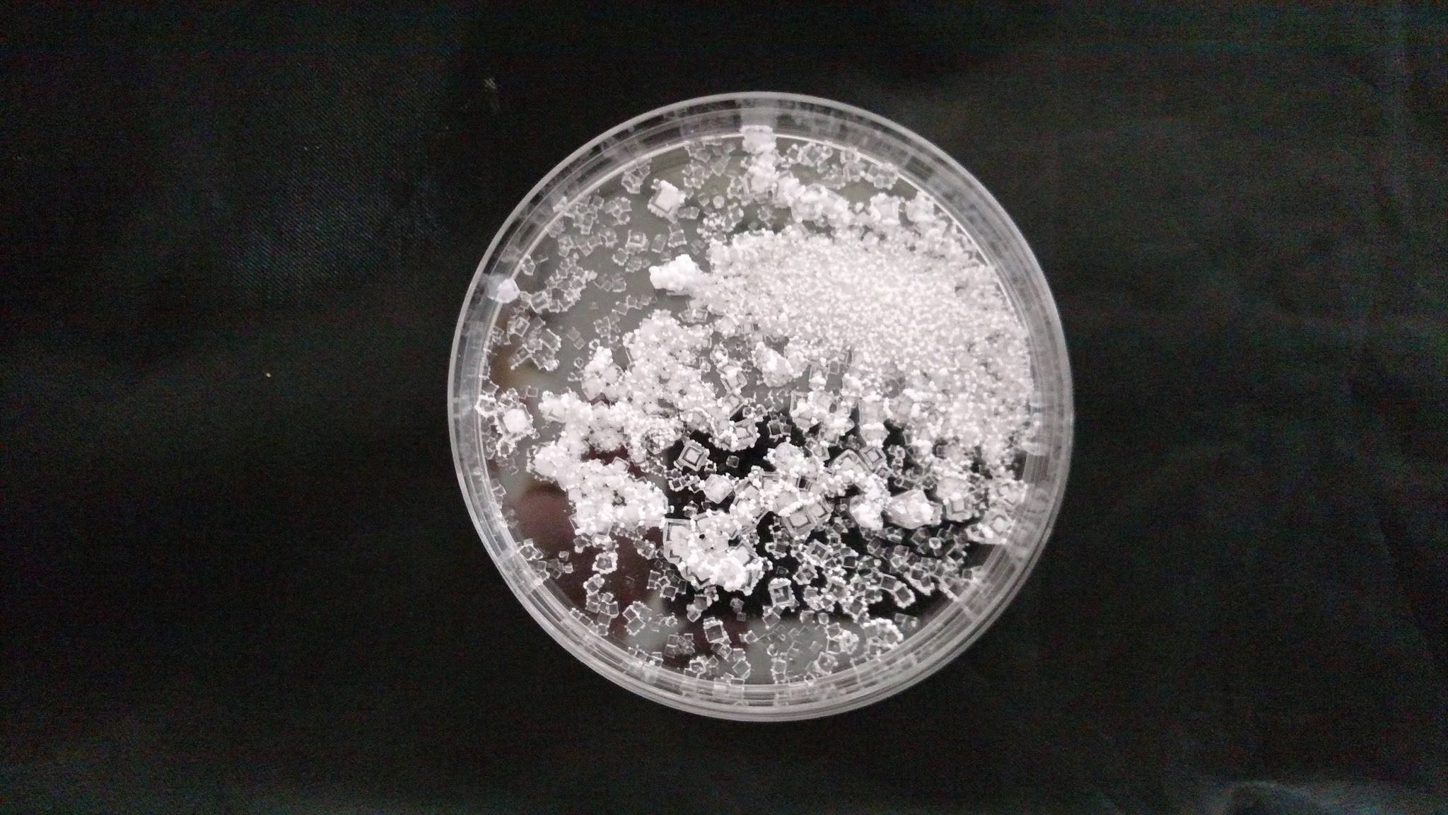

Magnesium sulfate crystals after 1 week. Liquid brine remains around/beneath the crystals and can be seen upon manipulation of the plates.
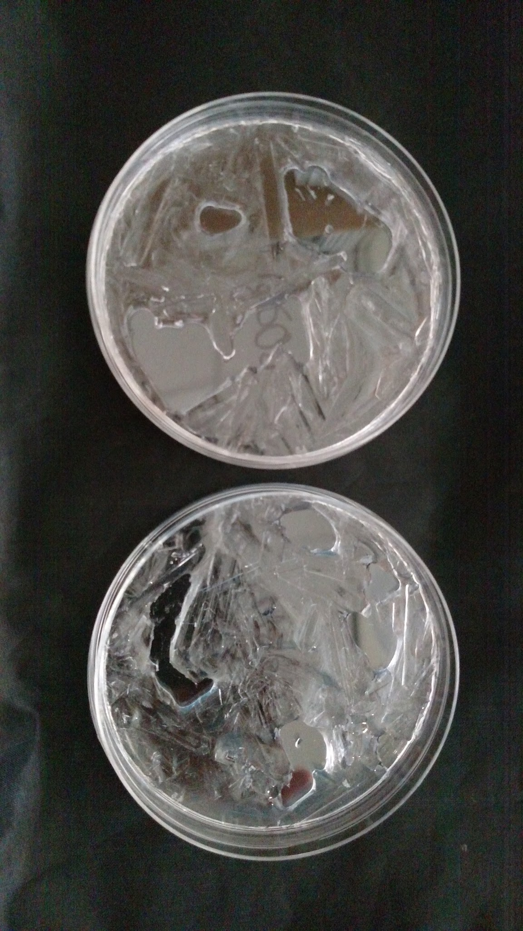

2. Crust creation in containers; qualitative & quantitative analysis: Note: this can be done by students, done by teacher as a demo, or students could simply be provided with data to graph and analyze.
- Students measure precise quantities of each saturated solution into small containers (suggested: 3 containers/sample type).
- Mass containers with liquid contents; record data.
- Leave containers open to the air to evaporate.
- Mass containers daily; record data.
- When mass ceases to change (either because all liquid has evaporated or because a salt crust has formed that is impermeable to evaporation), graph data.
- Discuss the significance of samples where water remains but evaporation ceases.
- Assess the crust (qualitatively and/or quantitatively) for its rigor, robustness, porosity/ability to trap water. Idea to test robustness: Mass a quantity of ball bearings; add them one at a time to the crust to see how many it can support before it breaks.

3. Crust creation on Martian soil analog: Have students add the various
supersaturated salt solutions (or just use the ones from #2 that actually made crusts?) to small containers of soil; let evaporate. View as above in order to evaluate robustness/porosity.
Martian regolith analog, available here: "The Martian Garden"

EXPLAIN: Part III, Analysis (will require level-appropriate teacher support, guidance and vocabulary):

Use the results from Part II to conduct a brainstorming session: how could a strong yet porous crust support microbial life? How/where would the water be? What space would microbial life inhabit with respect to such a crust? Guide students to recognize that a robust, porous crust could do two things: act as a protector for a liquid water environment below, and/or provide microbial habitat niches within the crust itself.

EXTEND: Can life survive in/underneath salt crusts? The Introduction to Life in an Extreme Environment Kit allows students to culture halophilic bacteria found inside salt crystals. The kit provides the salt crystals, culture medium, and detailed instructions. Once colonies are established, these colorful, motile bacteria may be observed microscopically.
- There are some microbiology lab skills kits linked at www.carolina.com too, that use halophiles as a “training organism.”
- The “Halobacteria in space” video linked here might be useful (this was hyperlinked on the Carolina Extremophiles Kit page).
- The website suggests that a DNA extraction could be attempted.

ELABORATE/EVALUATE: Part IV, Make Connections:

I. Have students read this article: Follow The Salt: Search for Mars Life May Focus on Driest Regions Also this article: “Searching salt for answers about life on Earth, Mars.” Ask them to discuss in groups, and or write a claim/evidence/reasoning response: Do your experimental results support the ideas put forward in these articles? Use your data and evidence from the articles to support your answers.

Expected conceptual connections:
- Liquid water is essential to life as we know it.
- Mars once had wet, salty oceans like ours.
- Mars’ oceans have disappeared over time. What happens when salt water disappears? Salt gets left behind.
- Left-behind salt can take on a number of forms; it depends on many factors, including the type of salt.
- Under certain circumstances, the right kind of salt can form a crust.
- The strength and porosity of a crust varies due to many factors, including type of salt.
- A strong crust could provide protection for a sub-crust life.
- A porous crust could provide reservoirs of liquid water and/or habitats for microbes.
- Mars has salts that probably can form strong, porous crusts; these salt crusts could thus be places to look for life.

II. Ask (this could be part of a class discussion, small group discussion, written evaluation, etc.): What other variables would need to be adjusted or manipulated in order to make these simulation experiments more Mars-like?

Expected responses should include the following at a minimum:
- Temperature (Mars is colder than typical classroom temperature environments on Earth; does temperature change the crystal formation process, and if so, how?)
- Pressure (Mars is much smaller than Earth and has far less atmosphere. How does lower atmospheric pressure/lower gravity affect the crystal formation process?)
- pH
- UV radiation

III. Ask students to suggest (either in large/small group discussion, written evaluation, etc.) ways to design additional experiments to simulate more Mars-like conditions. After class discussion about ways to simulate Mars conditions, students can read and discuss the UKCA PELS chamber article. Discussion can focus on comparing students’ suggestions for Mars simulation experiments to this one.

